ENGINEER 1C03 - Engineering Design & Graphics

Engineering 1 Cornerstone Design Project

Instructor: Dr. Nease

**Milestone 0**

Team **13**

Lab Section**: L03**

Vineeth Balachandran – balacv1 – 400238031

Yuntian Wang – wangy716 – 400234676

Tianze Zhang – zhant22 – 400208135

Jinnan Cheng – chengj64 – 400226963

As a future member of the engineering profession, the student is responsible for performing the required work in an honest manner, without plagiarism and cheating. Submitting this work with my name and student number is a statement and understanding that this work is my own and adheres to the Academic Integrity Policy of McMaster University and the Code of Conduct of the Professional Engineers of Ontario.

Submitted by [Vineeth Balachandran, 400238031]

Signature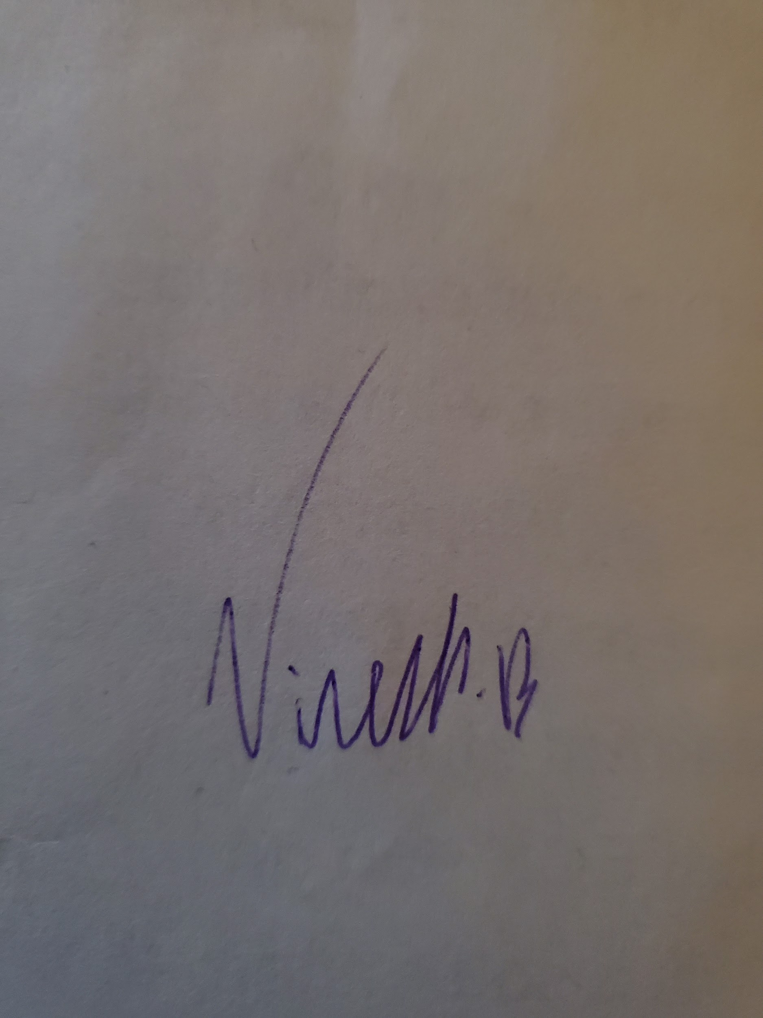

As a future member of the engineering profession, the student is responsible for performing the required work in an honest manner, without plagiarism and cheating. Submitting this work with my name and student number is a statement and understanding that this work is my own and adheres to the Academic Integrity Policy of McMaster University and the Code of Conduct of the Professional Engineers of Ontario.

Submitted by [Yuntian Wang, 400234676]

Signature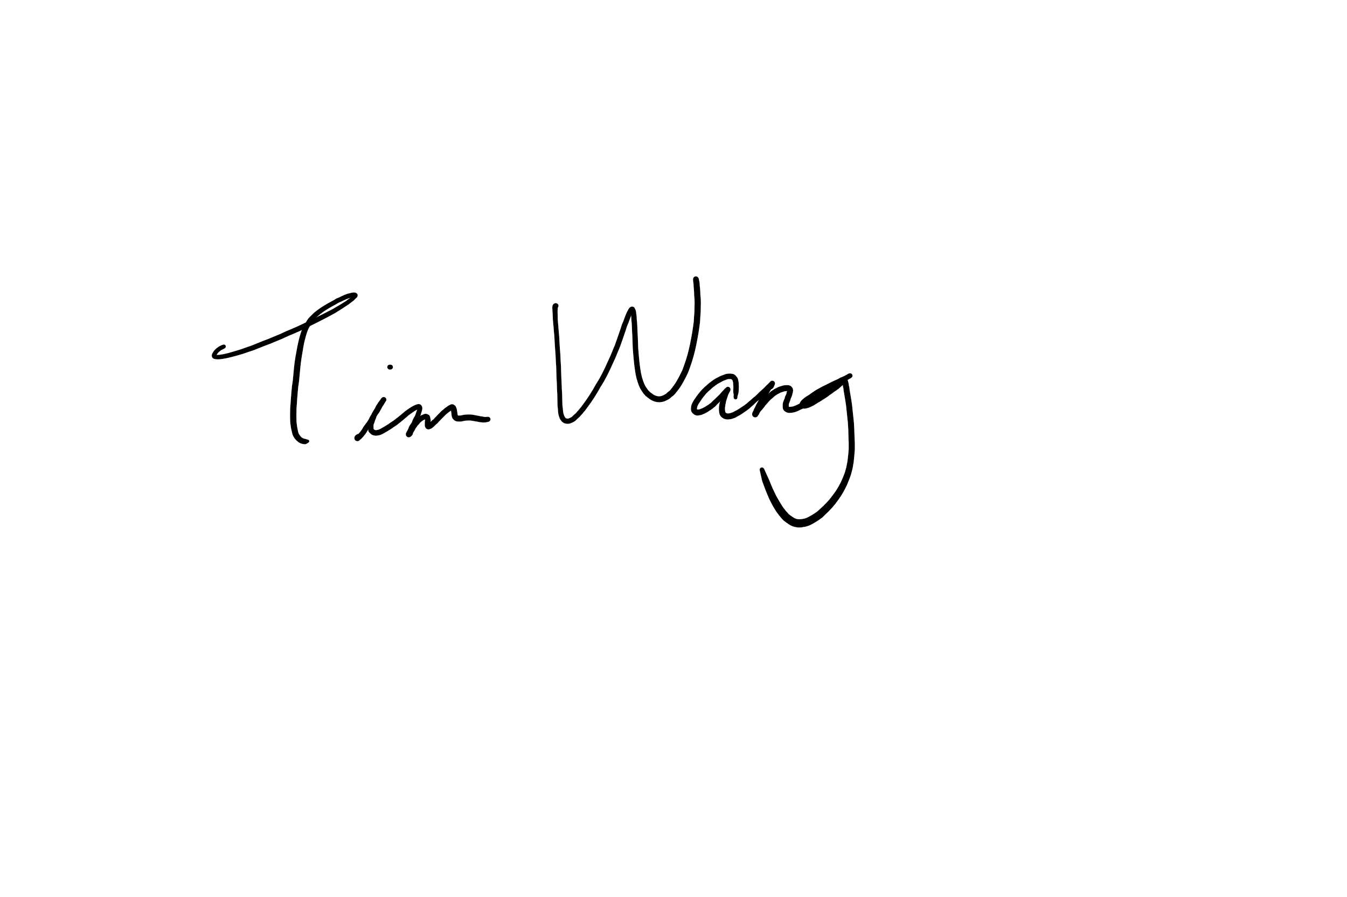

As a future member of the engineering profession, the student is responsible for performing the required work in an honest manner, without plagiarism and cheating. Submitting this work with my name and student number is a statement and understanding that this work is my own and adheres to the Academic Integrity Policy of McMaster University and the Code of Conduct of the Professional Engineers of Ontario.

Submitted by [Tianze Zhang, 400208135]

Signature 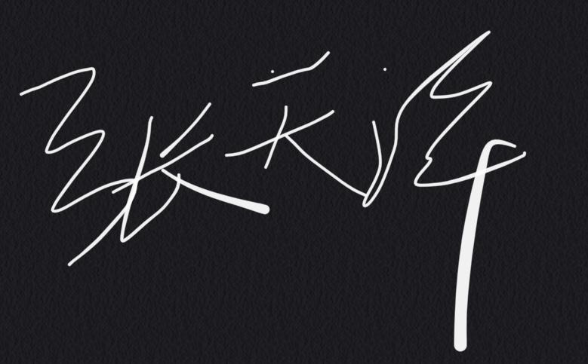

As a future member of the engineering profession, the student is responsible for performing the required work in an honest manner, without plagiarism and cheating. Submitting this work with my name and student number is a statement and understanding that this work is my own and adheres to the Academic Integrity Policy of McMaster University and the Code of Conduct of the Professional Engineers of Ontario.

Submitted by [Jinnan Cheng, 400226963]

Signature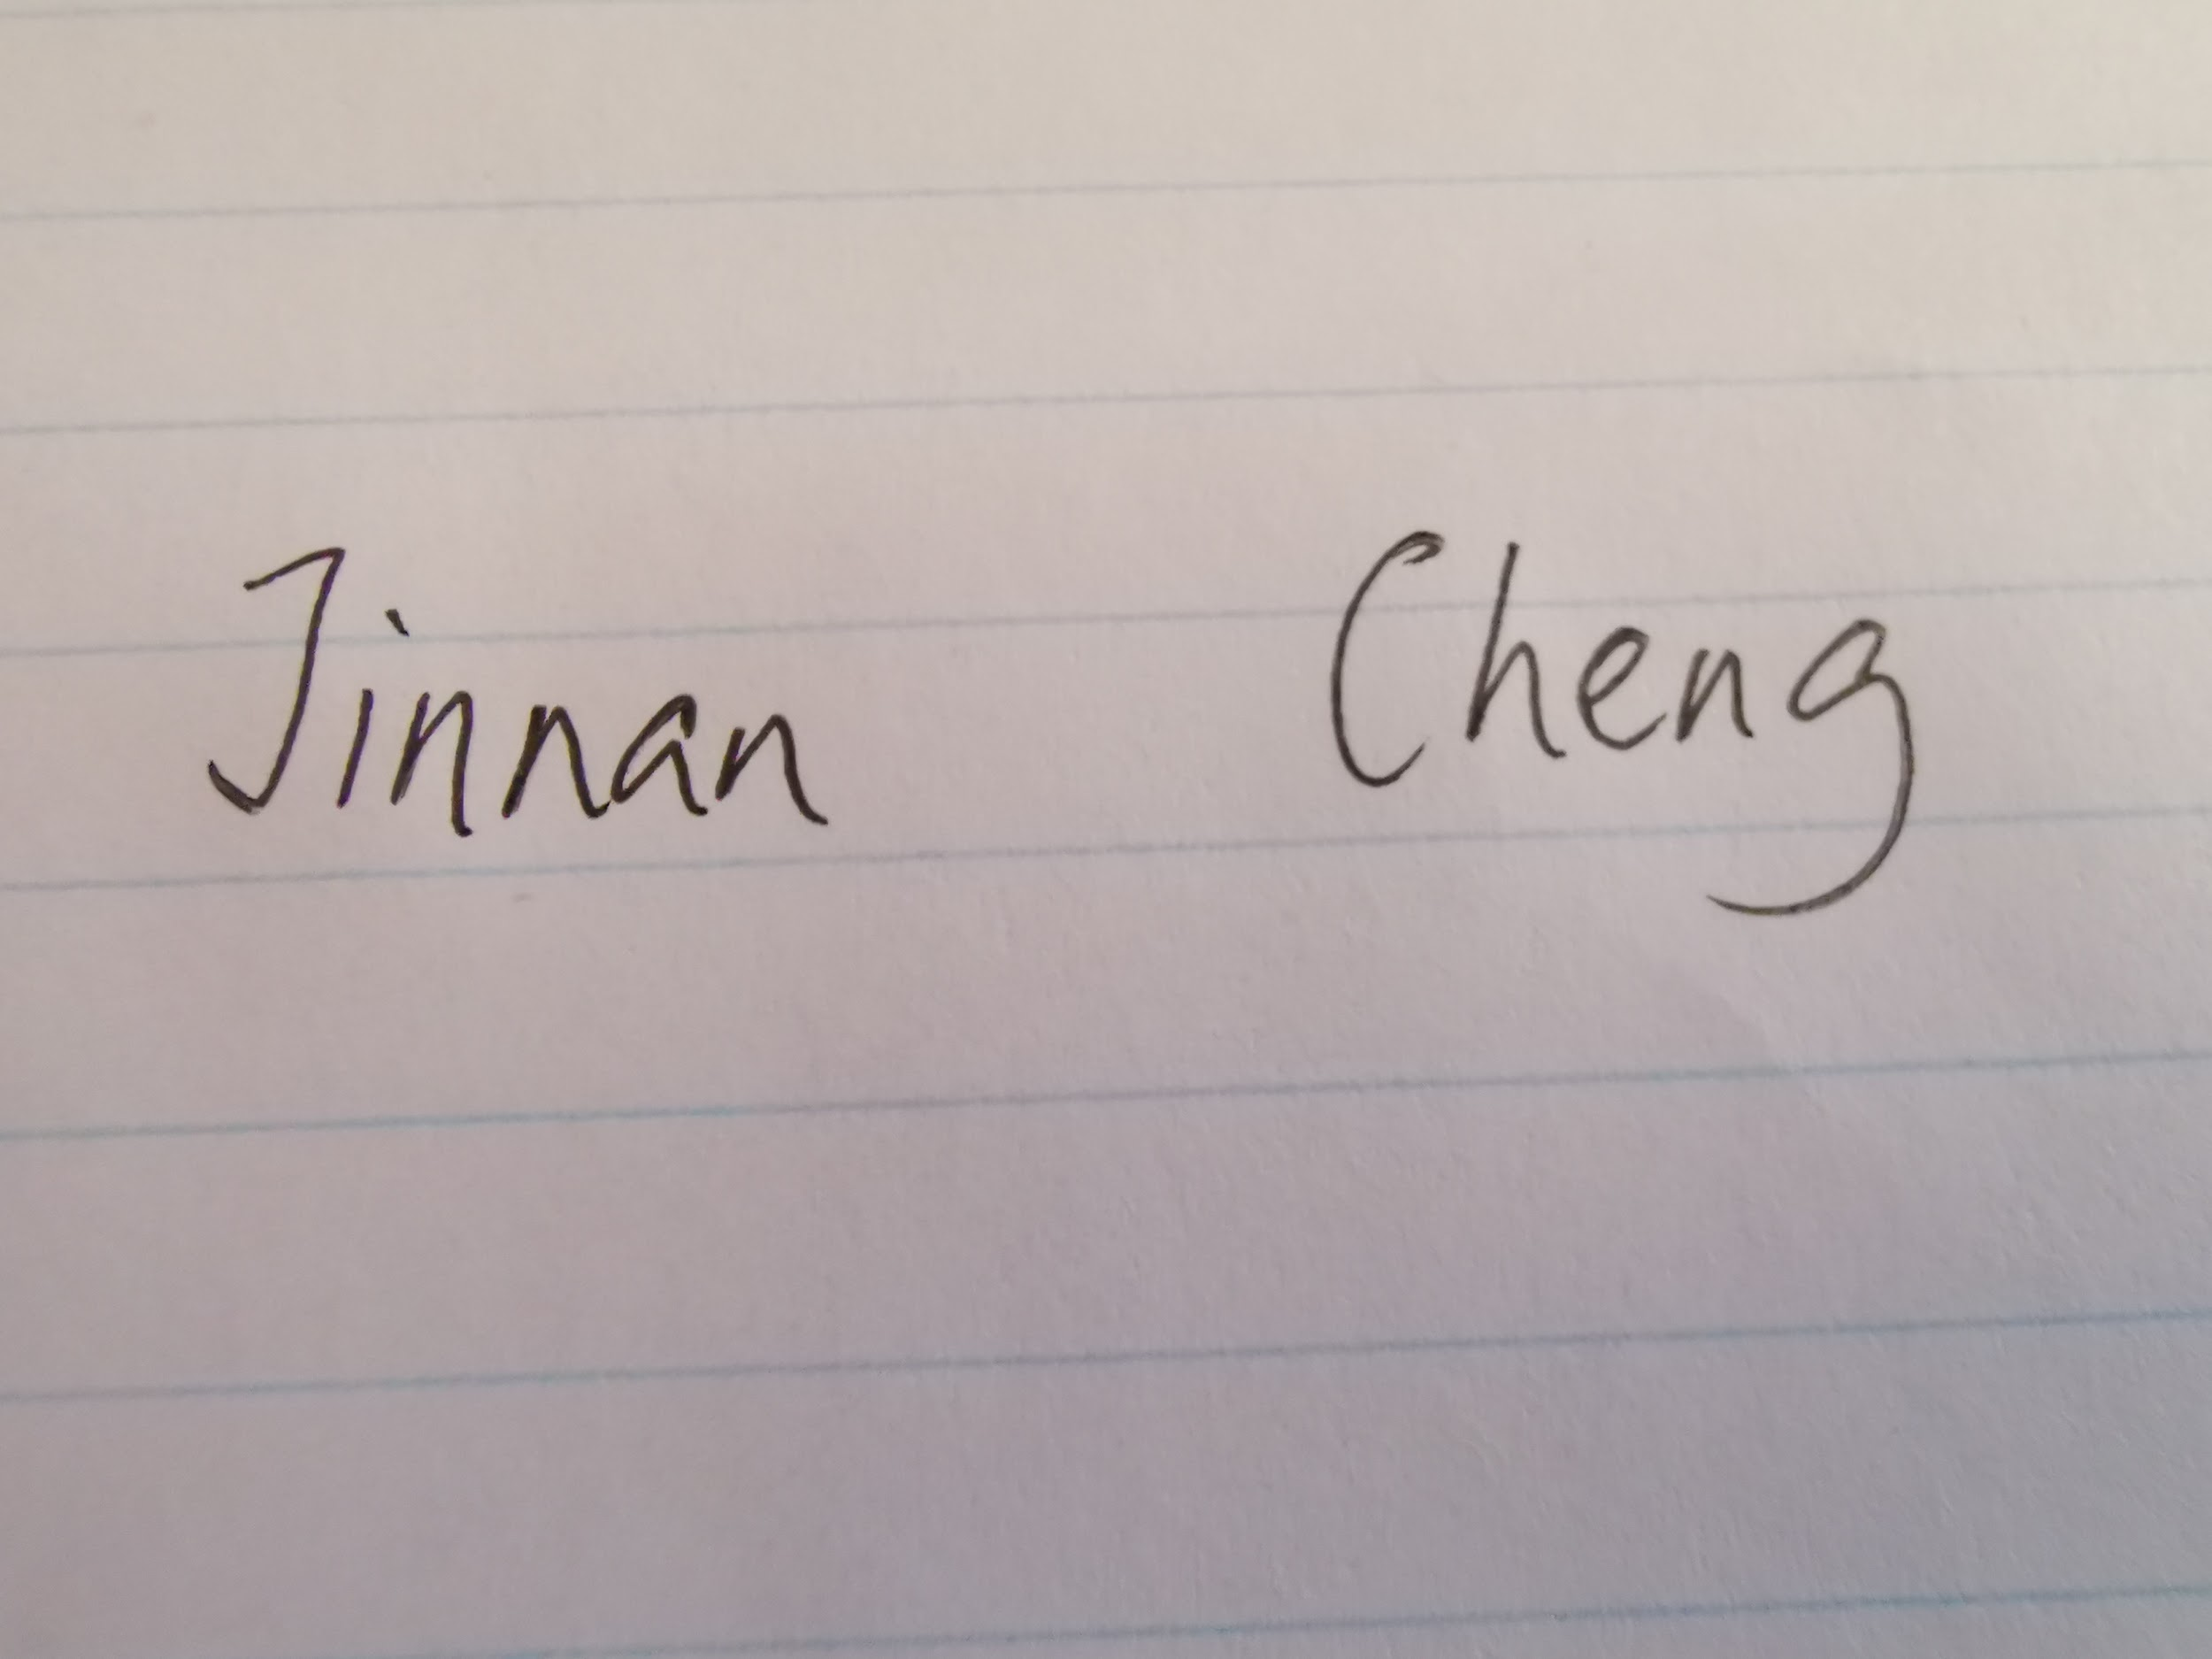

Contact Information

|  | Phone Number | Email Address |
| --- | --- | --- |
| Yuntian Wang | 6474647891 | wangy716@mcmaster.ca |
| Vineeth Balachandran | 6472054234 | balacv1@mcmaster.ca |
| tianze Zhang | 9053411682 | zhant22@mcmaster.ca |
| Jinnan Cheng | 4373504269 | chengj64@mcmaster.ca |

# Team Contract

1. All members will be as best as they can to complete their assigned work before deadlines.
2. All decisions will be discussed in the team and voted to reach a consensus before implementation.
3. All members will be inclusive and encourage every member in the team to express opinions.
4. All members will attend meetings or inform the team by email or phone before expected absences.
5. All meetings will occur at the agreed-upon time, or will occur if all members are informed at least two days in advance.

# Team roles and responsibilities

Tianze will pay attention to the deadline of all assignments, making sure every assignment submitted followed the rubric and guideline.

Yuntian will arrange anything related to team meetings, making sure the time for meetings will not contradict lessons and other personal issues.

Vineeth will take notes during each meeting, making sure every meeting and discussion we have are meaningful which will improve our design.

Jinnan will take care of the parts we designed. making sure all the gears and components we made can be assembled properly and perform the function that it should have.

Gantt Chart

